
CHEMISTRY 2AB 2013

NAME: __________________________TEACHER: ____________________________

TEST 1.
ATOMIC STRUCTURE & BONDING
QUESTION SHEET

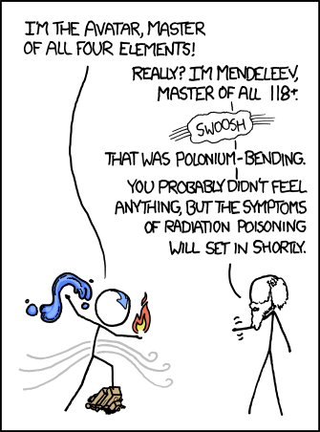

PART 1. MULTIPLE CHOICE (15 marks)

- Which one of the following atoms in its ground state has the greatest number of valence electrons?

  - Al
  - P
  - S
  - Si

- Which of the following electron configurations represents a neutral atom that forms a monatomic ion with a charge of –3?

  - 2, 3
  - 2, 8, 3
  - 2, 8, 4
  - 2, 8, 5

- Species ‘A’ is in Group 13 Period 3 while species ‘B’ is in Group 17 Period 2. Which of the following is the correct formula of the compound formed when the two species combine?

  - AlF₃
  - MgCl₂
  - NaCl
  - SrF₂

- Which of the following pairs contain one homogeneous and one heterogeneous mixture?

  - Salt water and Blood
  - Air and Multigrain bread
  - Silver wire and Gold nugget
  - Mud and garden mulch

- A covalent compound is most likely to be formed between atoms of elements having the electron configurations:

  - 2, 1 and 2, 8, 7
  - 2, 8, 1 and 2, 8, 6
  - 2, 8, 4 and 2, 8, 7
  - 2, 8 and 2, 8, 8

- Which of the following DOES NOT contain covalent bonding?

  - FeCl₃
  - CO₂
  - MgCO₃
  - SiO₂

- Which of the following have electron configurations similar to those of noble gases:

  - Ne, C, Cl, P
  - Be⁺, Na⁺ , O –, F
  - S ^{2–} , N ^{3–} , Mg ²⁺, Li ⁺
  - Ar– , Kr ⁺ , He ⁺ , Xe –

- Which statement best describes a metallic bond?

  - Each bond contains a pair of electrons shared by two atoms.
  - Electrons are delocalised and move around positive ions.
  - Electrons are transferred from one atom to another.
  - The bond is weak and particles easily separate.

- The table below gives information about three pure solids designated X, Y, Z.

 | X | Y | Z
Approximate Melting Point (ºC) | 800 | 114 | 1500
Electrical Conductivity in the Solid State | Nil | Nil | High
Electrical Conductivity in the Liquid State | High | Nil | High

Which of the following correctly describes the bonding present in X, Y & Z?

 | X | Y | Z
(A) | Covalent | Ionic | Metallic
(B) | Ionic | Covalent | Metallic
(C) | Metallic | Ionic | Covalent
(D) | Ionic | Metallic | Covalent

- The number of bonds and non-bonding pairs of electrons in N₂ is:

  - 3 bonds, 2 non-bonding pairs
  - 2 bonds, 3 non-bonding pairs
  - 2 bonds, 2 non-bonding pairs
  - 1 bond, 2 non-bonding pairs

- The number of ions in one formula unit of Magnesium Phosphate is:

  - 2
  - 3
  - 4
  - 5

- An atomic species Y has 20 electrons, 20 protons and 20 neutrons. Another species Z has 20 protons, 18 electrons and 21 neutrons. Which of the following statements is true?
- Y and Z are different elements
- Y and Z are isotopes
- Y is a negative ion
- Z is a positive ion

  - (i) and (iv) only
  - (ii) and (iv) only
  - (i) and (iii) only
  - (ii) and (iii) only

- The metal X has a sulfide with the formula XS. The correct formula for its chloride is

  - X₂Cl
  - XCl₂
  - XCl₃
  - X₂Cl₃

- The property that is used to classify elements in the same Group in the Periodic Table is similarity in

  - Mass number
  - Atomic number
  - Number of valence electrons
  - Number of neutrons in the nucleus

- Which of the following correctly classifies these substances in order:

Water, Table Salt, Vinegar, Gold

- Compound, Mixture, Mixture, Element
- Compound, Compound, Mixture, Element
- Element, Compound, Mixture, Element
- Mixture, Compound, Element, Element

NAME: ________________________________________ TEACHER: ____________________________

BELMONT CITY COLLEGE

YEAR 11 CHEMISTRY 2ACHE – 2013

TEST 1
Atomic Structure and Bonding

MULTIPLE CHOICE ANSWER SHEET
Mark the letter of the correct answer with X.
- [A] [B] [C] [D]
- [A] [B] [C] [D]
- [A] [B] [C] [D]
- [A] [B] [C] [D]
- [A] [B] [C] [D]
- [A] [B] [C] [D]
- [A] [B] [C] [D]
- [A] [B] [C] [D]
- [A] [B] [C] [D]
- [A] [B] [C] [D]
- [A] [B] [C] [D]
- [A] [B] [C] [D]
- [A] [B] [C] [D]
- [A] [B] [C] [D]
- [A] [B] [C] [D]

PLEASE DO NOT TURN THE PAGE UNTIL INSTRUCTED TO DO SO.

NAME: ___________________________________ DATE: __________________

TEST 1. ATOMIC STRUCTURE & BONDING QUESTION SHEET

PART 2. SHORT ANSWER SECTION (30 marks)

Write your answers on the spaces provided.

- Complete the Table below: (6 marks)

Element Name | Symbol | No. of Protons | No. of Neutrons | No. of Electrons | Mass Number | Atomic Number
Iodine | ₁₂₇  I  ⁵³ | 53 | 74 | 53 | 127 | 53
Potassium (ion) | ₃₉  K⁺  ¹⁹ | 19 | 20 | 18 | 39 | 19
Uranium | ₂₃₈  U  ⁹² | 92 | 146 | 92 | 238 | 92

- Write the electron configuration for (2 marks)

  - Silicon atom. 2,8,4

  - Calcium ion. 2,8,8

  - Phosphide ion. 2,8,8
  - The noble gas that both atoms resemble when they form NaF.
2,8
- Given the following pure substances: (6 marks)

CO₂, HCl, CaCl₂, Cu

Answer the questions below and explain your answer using your understanding of chemical bonding and particle interactions.

  - Which substance(s) would be the best conductor of heat? (2 marks)
Substance(s): copper (Cu) (½)
Explanation:
As a metal the delocalised electrons (½) are able to move through the lattice conducting heat. (1)

  - Which substance(s) would have the lowest boiling point? (2 marks)
Substance(s) CO₂& HCL (both for ½ mark)
Explanation:
Both are covalent molecules held together as a lattice or liquid weak intermolecular forces between molecules. (½)
The energy to overcome these forces is and separate these forces is low, therefore low boiling point (1)

  - Which substance(s) would be brittle in the solid form? (2 marks)
Substance(s): Calcium chloride (CaCl₂) (½)
Explanation:
As an ionic substance, its arrangement of alternating positive and negative ions produce a strongly bonded lattice (½) ,
When force is applied to the lattice, it causes ions with the same charge to line up next to each other which makes them repel and break up the lattice, causing it to shatter. (1)

- Give the Formula or Chemical Name of the following pure substances and identify the class of substance (metallic, ionic, covalent molecular, covalent network) it belongs to, based on its observable properties. (9 marks)

Name | Formula | Type of Bonding
Water | H₂O | CM
Chromium (III) sulfate | Cr₂(SO₄)₃ | I
Silicon Dioxide | SiO₂ | CN
Carbonic acid | H₂CO₃ | CM
Magnesium Hydroxide | Mg(OH)₂ | I
Carbon | C | CN
Ammonium Chloride | NH₄Cl | I
Hydrogen Peroxide | H₂O₂ | CM
Mercury | Hg | M
- Draw the electron dot diagrams to illustrate the bonds formed in the following compounds: (3 marks)

Substance | Electron Dot Diagram
potassium fluoride | 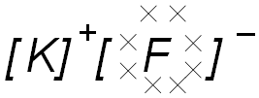
carbon disulfide | 
ammonium oxide | 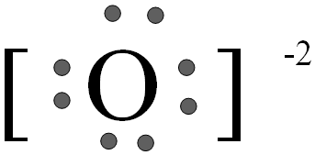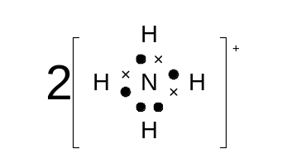

- Diamond is hard and does not conduct electricity while graphite is soft but is a good electrical conductor. Explain this difference using your understanding of what generally influences these properties in substances and specifically, the network lattice structure of diamond and graphite. (4 marks)

Diamond has a continuous network of strong covalent bonds throughout the entire structure, which are difficult to disrupt, so it is extremely hard. (1)
Graphite has very weak forces holding the layers of carbon atoms together, so they can slide across one another, causing it to be soft. (1)

Diamond has carbon atoms with all of their valence electrons involved in bonds, so none are free to carry charge making it a non-conductor. (1)
Graphite has carbon atoms with three of their valence electrons involved in bonds, and the fourth one free to carry charge making it a good conductor. (1)

END OF TEST

